# **Hard Disk Partitions**

**Steps To Create Hard Disk Partitions:**

1. Open Create and format hard disk partitions.

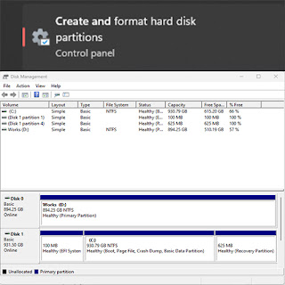

1. Please make sure that you have enough disk space before creating any disk partition. For example, if you want to create a disk partition with 40GB of storage space, your main available storage space capacity should be more than that.



1. Click Shrink Volume.

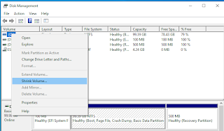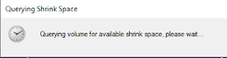

1. This is the storage that you will have for your new storage. It can be modified based on your needs. Please note that the size is MB. Click Shrink after you have confirmed your amount of space.

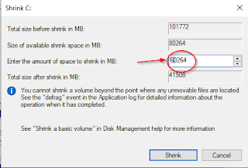

1. You will see that the main available storage space capacity has been reduced. From 99.39GB to 40.54GB.



1. The new hard disk is still not created yet but you can see that there is an Unallocated drive.

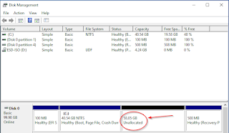

1. Right-click and click New Simple Volume.

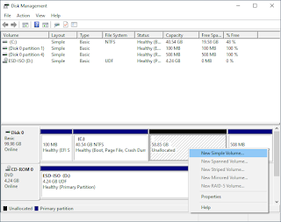

1. Click Next.

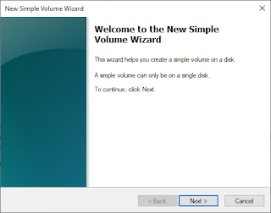

1. Just let it by default or change based on your need. Click Next.

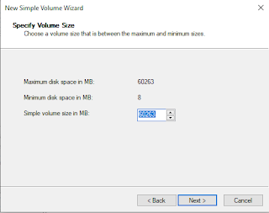

1. Just let it by default or change based on your need. Click Next.

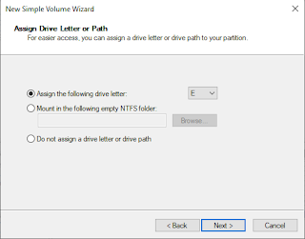

1. Just let it by default or change based on your need. Click Next.

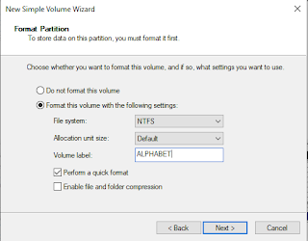

1. Click Finish.

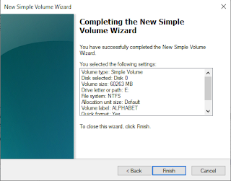

1. Here is your new drive.

